Multiple-choice section

|  |  |  |  |  |  |  |  |  |  |  |
| --- | --- | --- | --- | --- | --- | --- | --- | --- | --- | --- |
| Question | 1 | 2 | 3 | 4 | 5 | 6 | 7 | 8 | 9 | 10 |
| Answer | D | D | B | C | A | A | B | C | C | A |

Question 1 [9.1]

**A**

The highest power that appears in a quadratic equation is 2 (a squared term). **A** has a term raised to the power of 3.

Question 2 [9.3]

**C**

The constant term indicates to translate the parabola 4 units down.

Question 3 [9.1]

**C**

The graph is a parabola and is an example of a quadratic.

Question 4 [9.3]

**C**

The dilation factor is the coefficient of the term of the second degree. It is represented by *a* in *ax*2 + *bx* + *c*. The coefficient is 3, so the dilation factor is 3.

Question 5 [9.5]

**D**

2 units to the left *h* = -2

1 unit up *k* = 1

The general equation *y* = 2*x – h* + k becomes *y* = 4*x* + 2+ 1.

Question 6 [9.2]

**D**

*x*(*x* + 5) = 0

*x* = 0

*x* + 5 = 0

*x* + 5 – 5 = 0 – 5

*x* = -5

*x* = 0 or *x* = -5

Question 7 [9.7]

**D**

*y* 

*y* =

*y × x* = *k*

10*y* = 50

*y* = 5

Question 8 [9.4]

**B**

The graph of a circle is represented by the equation *x*2 + *y*2 = *r*2. To find the radius, take the square root of the *r*2 term. ****= 6 so the radius is 6.

Question 9 [9.6]

**A**

If *m* is directly proportional to *l m**l*

The equation of this relationship is *m* = *kl*.

Question 10 [9.5]

**B**

The power of *x* in the equation for a hyperbola is -1.

Multiple-choice total marks: 10

Short answer section

Question 11 7 marks [9.1]

**(a)** *y* = -*x*2 – 6*x* – 5

|  |  |  |  |  |  |  |  |
| --- | --- | --- | --- | --- | --- | --- | --- |
| *x* | -6 | -5 | -4 | -3 | -2 | -1 | 0 |
| *y* | -5 | 0 | 3 | 4 | 3 | 0 | -5 |

**(b)**

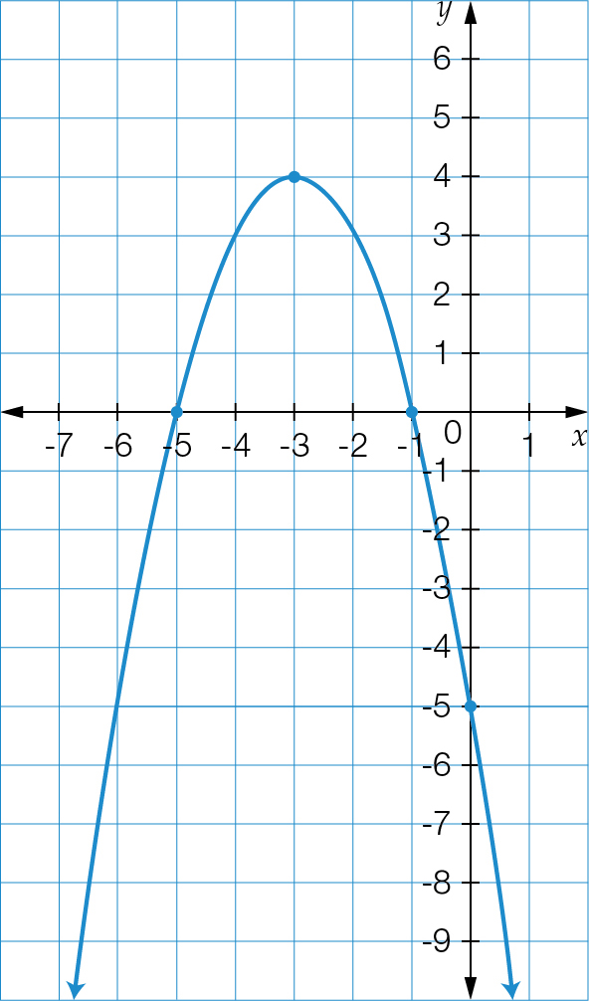

**(c)** From the graph, the turning point is (-3, 4).

Question 12 6 marks [9.1]

**(a)** The turning point is where the graph changes direction. This occurs at (-3, -1).

**(b)** The graph has a minimum turning point.

**(c)** The *y*-intercept is (0, 8).

**(d)** The *x*-intercepts are at (-4, 0) and (-2, 0).

**(e)** The equation of the axis of symmetry is *x* = -3.

Question 13 3 marks [9.2]

|  |  |  |
| --- | --- | --- |
| **(a)** (*x* – 2)(*x* + 5) = 0  *x* – 2= 0  *x* – 2 + 2 = 0 + 2  *x* = 2  *x* + 5= 0  *x* + 5 – 5 = 0 – 5  *x* = -5  *x* = 2 or -5 | **(b)** *x*2 – 7*x* = 0  *x*(*x* – 7) = 0  *x* = 0  *x* – 7 = 0  *x* – 7 + 7 = 0 + 7  *x* = 7  *x* = 7 or 0 | **(c)** *x*2 – 121 = 0  (*x* – 11)(*x* + 11) = 0  *x* – 11 = 0  *x* – 11 + 11 = 0 + 11  *x* = 11  *x* + 11 = 0  *x* + 11 – 11 = 0 – 11  *x* = -11  *x* = -11 or 11 |

Question 14 5 marks [9.2]

|  |  |  |
| --- | --- | --- |
| **(a)** *x*2 – 7*x* + 12 = 0  (*x* – 4)(*x* – 3) = 0  *x* – 4 = 0  *x* – 4 + 4 = 0 + 4  *x* = 4  *x* – 3 = 0  *x* – 3 + 3 = 0 + 3  *x* = 3  *x* = 4 or 3 | **(b)** *x*2 + 3*x* = 28  *x*2 + 3*x* – 28 = 0  (*x* – 4)(*x* + 7) = 0  *x* – 4 = 0  *x* – 4 + 4 = 0 + 4  *x* = 4  *x* + 7 = 0  *x* + 7 – 7 = 0 – 7  *x* = -7  *x* = -7 or 4 | **(c)** *x*2 – 8*x* + 16 = 0  (*x* – 4)(*x* – 4) = 0  *x* – 4 = 0  *x* = 4 |

Question 15 4 marks [9.3]

**(a)** The graph *y* = *x*2 has been translated down 4 units.

**(b)** The graph *y* = *x*2 has been reflected in the *x*-axis and translated up 1 unit.

**(c)** The graph *y* = *x*2 has been translated 3 units to the left and 2 units up.

Question 16 5 marks [9.4]

*h* = 2, *k* = -1, *r*= 2

centre: (2, -1)

(*x – h*)2 + (*y – k*)2 = *r*2

(*x* – 2)2 + (*y* – (-1))2 = 22

equation: (*x* – 2)2 + (*y* + 1)2 = 4

*h* = -1, *k* = -2, *r* = 3

(*x – h*)2 + (*y – k*)2 = *r*2

(*x* – -1)2 + (*y* – -2)2 = 32

equation: (*x* + 1)2 + (*y* + 2)2 = 9

Question 17 3 marks [9.5]

**(a)** an exponential relationship

**(b)** (0, 8)

**(c)** an asymptote

Question 18 4 marks [9.5]

**(a)** rectangular hyperbola

**(b)** *a* = 1, *h* = -1, *k* = -3

equation: *y* = – 3

**(c)** Horizontal asymptote is *y* = -3.

Vertical asymptote is *x* = -1.

Question 19 4 marks [9.6]

**(a)** *y* is directly proportional to *x*

**(b)** *y* *x*

*y* = *kx*

12 = 2*k*

*k* = 6

54 = 9*k*

*k* = 6

**(c)** Where *x* = 5,

*y* = 6 × 5

* y* = 30

Where *y* = 66,

*x* = 66 ÷ 6

* x* = 11

|  |  |  |  |  |
| --- | --- | --- | --- | --- |
| *x* | 2 | 5 | 9 | **11** |
| *y* | 12 | **30** | 54 | 66 |

Short answer total marks: 41

Extended answer section

Question 20 10 marks [9.1]

**(a)** *h* = -4*t*2 + 16*t*

|  |  |  |  |  |  |
| --- | --- | --- | --- | --- | --- |
| *t* | 0 | 1 | 2 | 3 | 4 |
| *h* | 0 | 12 | 16 | 12 | 0 |

**(b) (i)** (2, 16)

**(ii)** (0, 0) and (0, 4)

**(iii)** (0, 0)

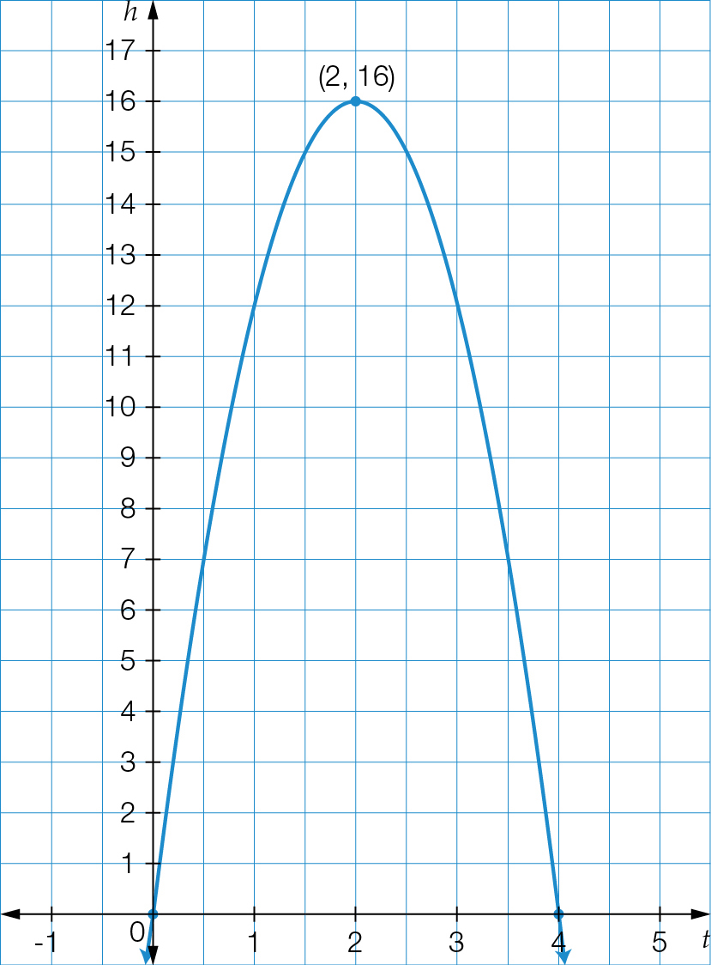

**(c)** From the graph, the maximum height of the ball is 16 m.

**(d)** at 2 seconds

**(e)** From the graph, the ball hits the ground at 4 seconds.

**(f)** at 1 second and at 3 seconds

Question 21 16 marks [9.4]

**(a)** (*x* – 1)2 + (*y* + 2)2 = 49

centre: (1, -2)

**(b)** radius: √49 = 7

**(c)** *x* min = -6, *x* max = 8, *y* min = -9, *y* max = 5

Point *A*: (-6, -2); Point *B*: (8, -2); Point *C*: (1, 5); Point *D*: (1, -9)

**(e)**

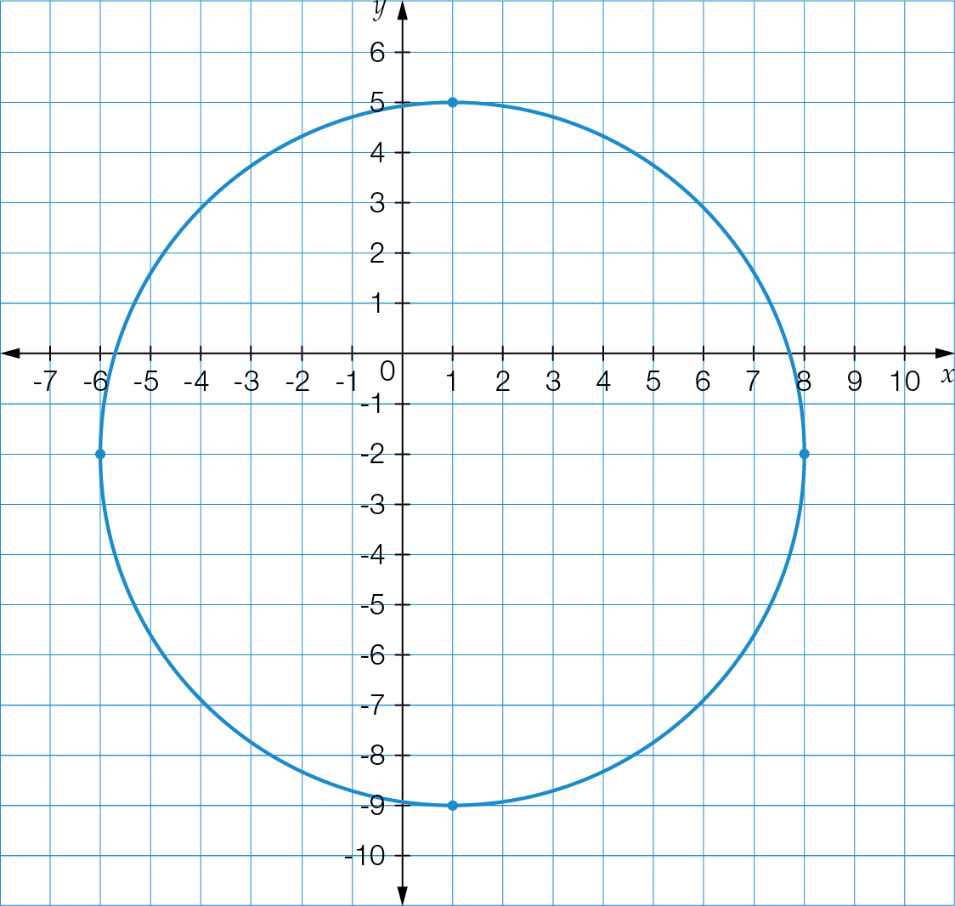

**(f) (i)** (2, 4) – inside

**(ii)** (-5, 3) – outside

**(iii)** (8, 2) – outside

**(iv)** (3, 4) – inside

Question 22 6 marks [9.7]

**(a)** The relationship between *x* and *y* is inversely proportional because as *x* is increasing, *y* is decreasing.

**(b)** 1  30 = 30

2  15 = 30

3  10 = 30

5  6 = 30

*****k* = 30

**(c)** *y* 

*y* = 

*y* = 

**(d)**

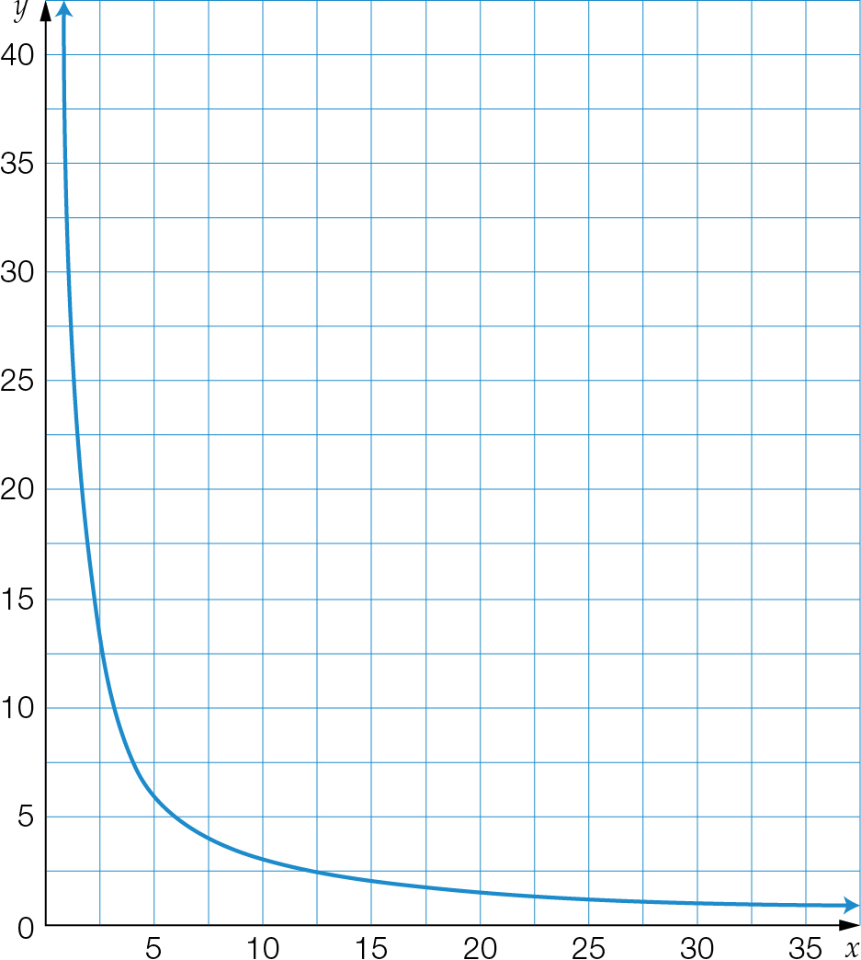

**(e)** Where *x* = 30:  
 *y* = 

*y* = 1

Extended answer total marks: 32

TOTAL test marks: 83